

f14g26 - Developer’s Guide

IDS 517 – Enterprise Application Document

|  |  |
| --- | --- |
| Group Members | |
| Krishnakanth Panakarajupally | kpanak2@uic.edu |
| Ganesh Satyamsetti | gsatya2@uic.edu |
| Sreekanth Chinthagunta | schint9@uic.edu |
| Siddhartha Varma Gadiraju | sgadir2@uic.edu |

**MVC Architecture:**

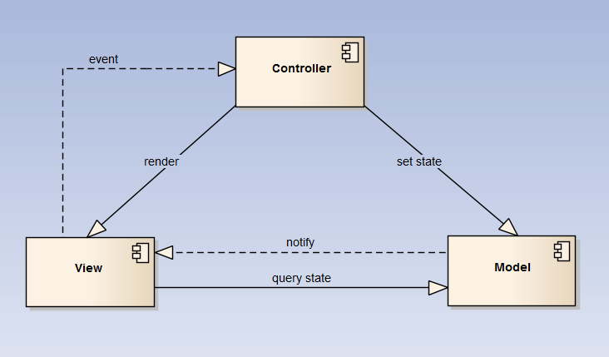

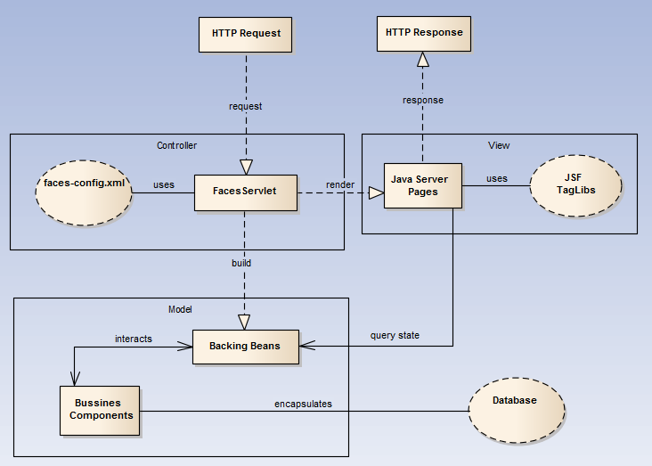

**Overview:**

|  |  |
| --- | --- |
| Class Name | Description |
| ConnectionManager.java | Database Access Object (DAO) with methods to connect to database. Contains the database credentials such as Database URL, JDBC Driver, Username and Password |
| DbTransactions.java | Contains methods to perform operations involving database interactions such as create application table, insert user and log data, query user data, etc. |
| DbBean.java | Execute DML and DDL operations, query data and prepare ResultSet to create Result object to display in the JSP. |
| FileActionBean.java | Handles the file import, parse and export functionality |
| MathUtil.java | Calculate statistics and draw plots. |
| MessageBean.java | Bean to store messages |
| PopulateList.java | Used to populate the list of tables and list of columns drop down lists. |
| ResultsBean.java | Used to store the statistical calculation output |
| UserBean.java | Used to store the user information |

**Application Flow Diagram:**



**UML Diagrams:**

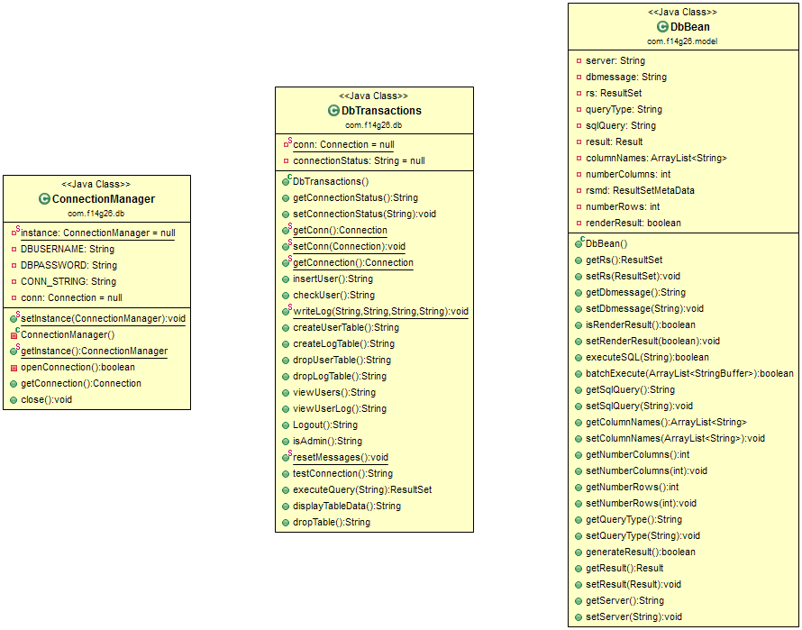

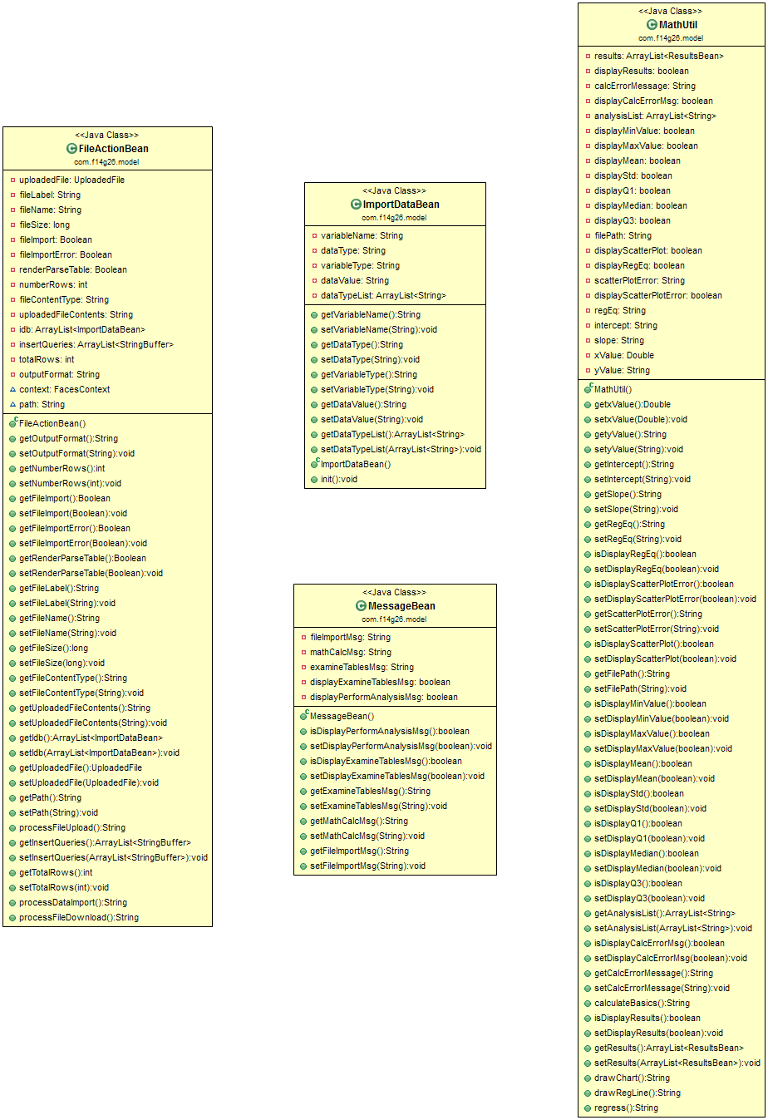

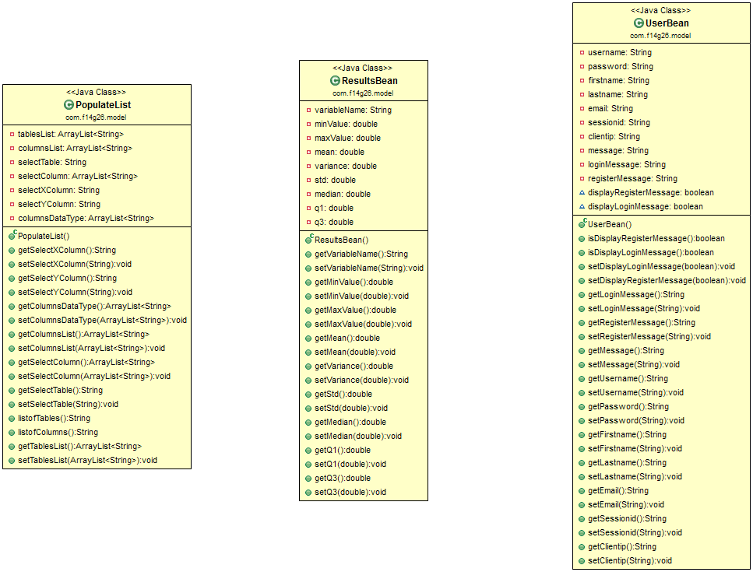

**Reference:**

[**http://matters4j.blogspot.com/2012/08/jsf-architecture.html**](http://matters4j.blogspot.com/2012/08/jsf-architecture.html)